Project Name
Smart Task Manager
Project Idea
A web-based task management system designed to help organizations manage and track employee tasks efficiently.
Admins can create, assign, and monitor tasks, while employees can view and update their progress in real-time.
The system is built using Spring Boot, secured with JWT authentication, and deployed using Docker, Nginx, and Kubernetes, with Prometheus & Grafana for system monitoring and performance tracking.
Team Members (pentaRae)
Mostafa Taha
Mariem Sayed
Haneen Akram
Abdelrahaman Elginidy
Mohamed Essam
George Ayman
Work Plan
- Research & Analysis
· Define system requirements and user needs
· Identify key features for admins and employees
· Create audience personas (Admin, Employee)
- · Visual Identity
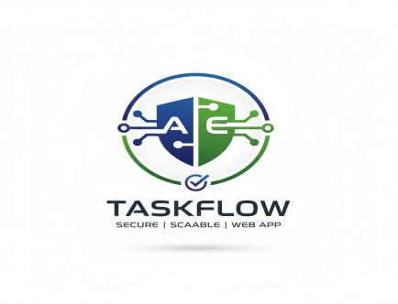
- Main Designs
  - 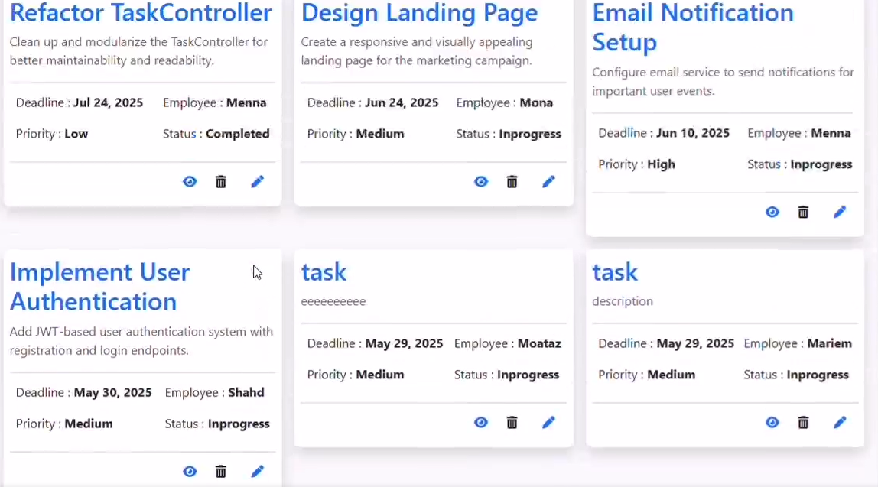
  - 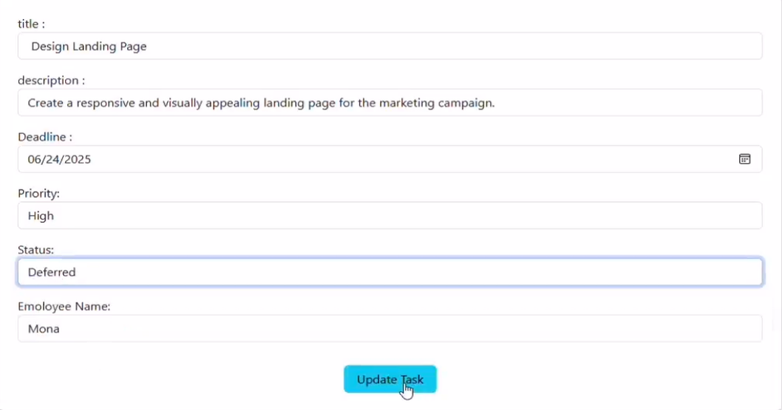
  - 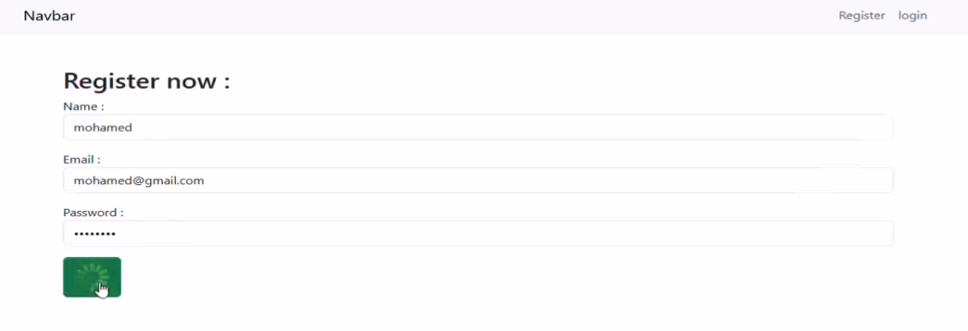
- Complementary Products
- Review & Finalization
- Final Presentation
Roles & Responsibilities

- KPIs (Key Performance Indicators) – Metrics for project success (e.g., response time, system uptime, user adoption rate).
Metric | Target | Description
System Uptime | ≥ 99% | Stability and availability of the deployed app
Average Response Time | ≤ 500ms | API performance and efficiency
Task Completion Accuracy | ≥ 95% | Correct handling of task status updates
User Adoption Rate | ≥ 80% | Percentage of users activelyusing the system
Error Rate | ≤ 2% | Number of failed requests or exceptions
Deployment Success Rate | 100% | Smooth deployment through Docker/Kubernetes
Monitoring Alerts | ≤ 5 per week | Prometheus alerts within acceptable range

Instructor
*Ahmed Gamin

Project Files
You can find the full project files here
License
- This project is licensed under the MIT License – allowing free use, modification, and distribution with attribution.

